**Components Document**

***Author: William Kerr***

**Table of Contents**

Contents

Solar Panels: 3

Introduction: 3

Datasheet: 3

Charge Controller: 3

Introduction: 3

Features: 3

Monitoring: 3

Internal ADC chips: 3

Temperature Data: 4

Status Data: 4

MPPT Data: 4

Charger Data: 4

Daily Data: 4

Current Charge Settings: 5

Recommended Accessories: 5

Remote Temperature Sensor 5

RS-232 to USB cable 6

Batteries: 6

Introduction: 6

Datasheet: 6

Battery Management System: 6

Introduction: 6

Features: 6

Monitoring: 6

System Status 6

System status and Individual Cells: 6

Statistics 6

**Necessary Accessories:** 6

Cell Isolators 6

Cell Modules 6

CAN Cell Group Module 6

**Recommended Accessories:** 6

Current Sensor 6

Sensors – Faculty 6

Introduction: 6

Temperature and Humidity Sensor: 6

Details: 6

Light Sensor: 6

Details: 6

Faculty Microcontroller 7

Explanation: 7

Features: 7

Sensors – Student 8

Water Temperature sensor: 8

Student Microcontroller 9

Heater – Battery pack 10

Explanation: 10

Cooler – Battery pack 11

Explanation: 11

AC outlet 12

Accessories: 14

GSM module 17

SIM card 18

Web Server 19

# Solar Panels:

## Introduction:

This is a client request.

These solar panels let certain wavelengths of light through them, and absorb the rest of the spectrum.

This allows plants to grow inside.

Model: LUMO 20M100GH

Quantity: 24x

Company: Soliculture

Company Website: <http://www.soliculture.com/>

Product Page: <http://www.soliculture.com/product/>

## Datasheet:

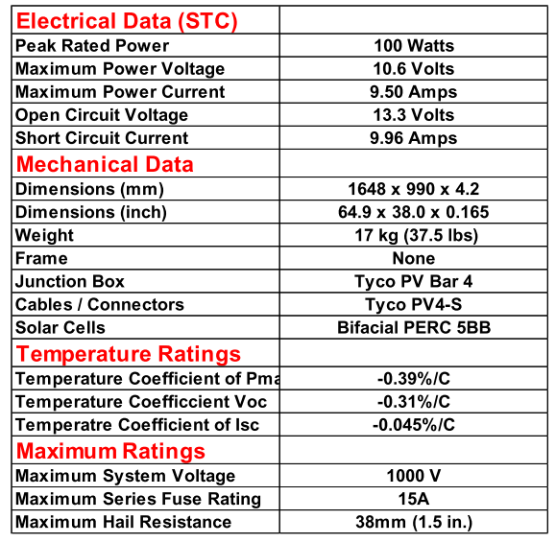

# Charge Controller:

## Introduction:

Solar panels cannot charge batteries directly. 1.) They have unstable voltages, and thus should not be connected directly to the battery. 2.) Batteries with different chemical compositions charge differently. Solar panels do not charge them properly. We must have a charge controller. I like this one since it is not only custom-programmable, you can get a significant amount of data from it.

Model: MORNINGSTAR TS-MPPT-60 TriStar MPPT 150V

Company: Morningstar

Company Website: [https://www.morningstarcorp.com](https://www.morningstarcorp.com/)

Product link: <https://www.morningstarcorp.com/products/tristar-mppt/>

Quantity: 2x

## Features:

Customizable Charge Settings

Great networking capabilities

RS-232 electrical interface for Microcontroller communication.

Uses royalty-free MODBUS protocol for easy data harvesting

Operating Range: -40C to 40C

Up to 60A continuous battery current

Compatible with 12V, 24V, and 48V battery systems

Maximum 150V solar panels in series

Keyholes for mounting

Uses TrakStar MPPT technology to track the maximum power point of the solar panels.

Temperature compensation

## Monitoring:

Tristar Morningstar MPPT can monitor:

### Internal ADC chips:

Battery Voltage

Battery Terminal Voltage

Battery Sense Voltage

Array Voltage (of the solar panels)

Battery Current

Array Current (of the solar panels),

12V supply,

3V supply,

meterbus voltage,

1.8V supply,

Reference voltage

### Temperature Data:

Heatsink Temperature

RTS temperature

Battery Regulation Temperature

### Status Data:

Battery Voltage (slow)

Charging Current (slow)

Minimum Battery Voltage

Maximum Battery Voltage

Hourmeter

Faults raised

Alarms raised

LED state

DIP switch status

### MPPT Data:

Output Power

Input Power

Max power of last sweep

Vmp of last sweep

Voc of last sweep

### Charger Data:

Charge state

Target Regulation Voltage

Ah charge resettable:

Ah charge total

kWhr charge resettable

kWhr charge total

### Daily Data:

Battery Voltage Minimum

Battery Voltage Maximum

Input Voltage Maximum

Amp Hours accumulated

Watt hours accumulated

Minimum Power output

Minimum temperature

Maximum temperature

Time in ab stage

Time in equalize stage

Time in float stage

Alarms of the day

Faults of the day

Flags of the day

### Current Charge Settings:

EV_absorp

EV_float

Et_absorp

Et_absorp_ext

EV_absorp_ext

EV_float_cancel

Et_float_exit_cum

EV_eq

Et_eqcalendar

Et_eq_above

Et_eq_reg

Et_battery_service

EV_tempcomp

EV_hvd

EV_hvr

Evb_ref_lim

ETb_max

Etb_min

Elb_lim

EVa_ref_fixed_init

EVa_ref_fixed_pet_init

LED settings

EV_soc_g_gy

EV_soc_gy_y

EV_soc_y_yr

EV_soc_yr_r

## Recommended Accessories:

### Remote Temperature Sensor

Explanation:

The greenhouse naturally changes temperature more than 5 C during the year. The Morningstar Corporation recommends that you add the RTS sensor for the Charge Controller to operate more effectively.

Model: Remote Temperature Sensor

Quantity: 2x

Company: Morningstar

Company Website: <https://www.morningstarcorp.com/>

Product Page: <https://www.morningstarcorp.com/products/remote-temperature-sensor/>

### RS-232 to USB cable

Explanation:

RS-232 must be converted to USB format for easy monitoring by the Raspberry Pi. Luckily, I don’t have to reinvent the wheel. I can simply use this cable.

RS-232 Male to USB male

Model: C2G 26886 USB to DB9 Serial RS232 Adapter Cable, Blue (1.5 Feet, 0.45 Meters)

Quantity: 2x

Company: C2G

Company Website: <https://www.cablestogo.com/>

Product Page: <https://www.amazon.com/C2G-Cables-26886-Serial-Adapter/dp/B000067RVJ>

# Batteries:

Lithium-ion Battery Cell

## Introduction:

Solar panels do not produce power all the time. Even when they do produce power, they often don’t produce enough power to satisfy the consumer. During the day, when the solar panels produce the most power, the consumer often isn’t using the system. To resolve this, we need to have a battery pack. During the day, the battery pack will be charged by the solar panels, and during the evening, the battery pack will be discharged by the consumer.

Model: IFP71/180/278-CA180FI

Quantity: 8

Company: CALB

Company website: <http://www.calbusainc.com/>

Product Page: <https://www.ev-power.eu/LiFePO4-small-cells/Prismatic/CALB-CA180FI-Lithium-Cell-LiFePO4-3-2V-180Ah.html>

## Datasheet:

# Battery Management System:

## Introduction:

Batteries don’t discharge evenly. Every battery has its own individual chemistry due to imperfections in the manufacturing process. If we discharge batteries unevenly, one battery could be worn out while another battery remains untouched. To resolve this, we use a Battery Management System.

Model: G1 EMUS BMS control unit

Quantity: 1

Company: Emus

Company Website: <https://emusbms.com/>

Product Page: <https://emusbms.com/product/g1-bms-control-unit>

## Features:

Automatically controls the battery operation process utilizing various interfaces for measurement, control, data exchange, configuration and indication.

Works with any charge controller

Application:

Any lithium chemistry, series connected battery pack of up to 254 cells if using serial cell communication

Any lithium chemistry, series connected battery pack, or pack of multiple parallel strings, up to 8128 cells total, if using EMUS CAN Cell Group Modules.

Storage Temperature: -40 C to 95 C

Operation Temperature: -40 C to 80 C

USB interface for Microcontroller reading

Proprietary serial interface for cell communication

## Monitoring:

BMS control unit can monitor:

### System Status

Battery Charge

Charger Status

Current and Voltage

Distance and Energy (if applied to an electric vehicle)

BMS status

Time and Date

Version Number

### System status and Individual Cells:

Battery Balancing Rate

Temperature

Battery Voltage

### Statistics

Has an internal events log (each event happening at a recorded time)

Has a statistics log at a recorded time. Possible statistics to log:

- Total Discharge

- Total Charge

- Total Discharge Energy

- Total Charge Energy

- Total Discharge Time

- Total Charge Time

- Total Distance

- Max Discharge Current

- Max Charge Current

- Min Cell Voltage

- Max Cell Voltage

- Max cell Voltage Difference

- Min pack voltage

- Max pack voltage

- Min Cell Module Temperature

- Max Cell Module Temperature

- Max Cell Module Temperature Difference

- Protection Counts (undervoltage, overvoltage, discharge overcurrent, charge overcurrent, cell module overheat, leakage protection, no cell communication, low voltage power reduction, high current power reduction, high cell module temperature power reduction, charger connect, charger disconnect, cell overheat, high cell module temperature power reduction)

- Miscellaneous counts (# of Preheat stages, Precharge stages, main charge stages, balancing stages, charging finished stages, charging errors, charging retries, trips, charge restarts)

- Min Cell Temperature

- Max Cell Temperature

- Max Cell Temperature Difference

## **Necessary Accessories:**

### Cell Isolators

The BMS system requires that you have isolators to protect the main module.

Only works if only 1 group of batteries is used.

Model: G1 Top/Bottom Isolator

Company Website: <https://emusbms.com/>

Product Page: <https://emusbms.com/product/g1-top-bot-isolator>

Quantity: 2x

### Cell Modules

Every battery must have its own cell module.

Different batteries require different cell modules.

You can find all types of cell modules here:

<https://emusbms.com/product-category/cell_modules>

The standard solution is the A/B type, so that’s what we’re going with.

We must order this package for each battery.

EMUS BMS Cell Module A – 1x

EMUS BMS Cell Module B – 1x

Ring Terminal M8 – 2x

Communication Cable – 16cm – 2x

#### Ordering details:

Model: G1 Cell Module – A/B type

Company: Emus

Company Website: [https://emusbms.com](https://emusbms.com/)

Product Page: <https://emusbms.com/product/g1-cell-module-ab>

Quantity: 8x

### CAN Cell Group Module

We need to group batteries into groups.

Since the batteries we picked are 3.2V, we group batteries into groups of 4.

Model: G1 CAN Cell Group Module

Company: Emus

Company Website: <https://emusbms.com/>

Product Page: <https://emusbms.com/product/g1-can-cell-group-module>

Quantity: 2x

## **Recommended Accessories:**

### Current Sensor

In order to monitor current dispensing from the batteries to the load, you must have a current sensor. It’s not necessary for operation, but it’s recommended to have one. This one works using the hall effect, so it does not require contact with the wires; it only needs to have the wire running through its hole.

Model: G1 Loop Style Dual Range Current Sensor

Company: Emus

Company Website: <https://emusbms.com/>

Product Page: <https://emusbms.com/product/g1-loop-style-dual-range-current-sensor>

Quantity: 1x

# Sensors – Faculty

## Introduction:

The client wants their own sensors exclusive for faculty. They want to measure temperature, humidity, and light. I propose that we use two classes of sensors for this: a Temperature and Humidity Sensor, and a

The product page and the datasheet are different pages because I want to purchase a whole breakout board instead of homebrewing my own board for it. It’s easier to have a breakout board, and easier to order a new breakout board from ADAFRUIT than it would be to order a PCB, and solder the components onto it.

## **Temperature and Humidity Sensor:**

Model: BME280

Company: Bosch

Company Website: <https://bosch.us/>

Product Page: <https://www.adafruit.com/product/2652>

Datasheet: <https://cdn-shop.adafruit.com/product-files/2652/2652.pdf>

### Details:

+-3% accuracy for humidity

+-1% accuracy for temperature

1s response time maximum

Operating range: -40C to 85C

I2C interface

Also can measure pressure if necessary

## **Light Sensor:**

Model: VEML7700

Quantity: 2

Company: Vishay Semiconductors:

Company Website:

Product Page: <https://www.adafruit.com/product/4162?gclid=EAIaIQobChMIyOmfve7Q4wIV6f_jBx07fQ1yEAQYASABEgJti_D_BwE>

Datasheet: <https://www.vishay.com/docs/84286/veml7700.pdf>

### Details:

High resolution: 0.0036 lux/ct at night, 1.8 lux/ct in bright sunlight

Maximum 120,000 lux (bright sunlight)

I2C interface

# Faculty Microcontroller

## Introduction:

There must be a master microcontroller to harvest data, process it, and send it to the server.

Model: Raspberry Pi 3 Model B+

Quantity: 1

Company: Raspberry Pi

Company page: <https://www.raspberrypi.org/>

Product Page: <https://www.raspberrypi.org/products/raspberry-pi-3-model-b-plus/>

## Features:

1.6GHz ARM processor

Python interpreter

4 USB ports

20 GPIO pins

I2C, UART, and SPI interface

Runs Linux

Bluetooth and Wi-Fi Capabilities

# Sensors – Student

Explanation:

As an optional feature, the client would like the system to be capable of having students be able to use their own sensors. Here are some potentially useful sensors for students:

## Water Temperature sensor:

Model: DS18B20

Quantity: 1

Company: Maxim Integrated

Company Website: <https://www.maximintegrated.com/en.html>

Product Page: <https://www.adafruit.com/product/381?gclid=EAIaIQobChMIh5e--PmU4wIViJWzCh3vLA9XEAQYASABEgKZSfD_BwE>

Details:

Interface: One-wire

Range: -55 C to 125 C

Accuracy: +- 0.5 C from -10 C to 85 C

Programmable resolution from 9 bits to 12 bits

# Student Microcontroller

Explanation:

Instead of having every student plug into one microcontroller (which would require a lot of cables running around), I propose that for every experiment, we have a separate microcontroller that the student can take with them. The Raspberry Pi 3 Zero W is a great candidate for this. It’s Bluetooth enabled, so they aren’t burdened by a cable length. It’s just as powerful as the normal Raspberry Pi, with the addition of writing their own code for their own sensors.

We will have to use our own sensor shields.

Model: Raspberry Pi 3 Zero W

Quantity: 2

Company: Raspberry Pi

Company Website: <https://www.raspberrypi.org/>

Product page: <https://www.adafruit.com/product/3400?gclid=EAIaIQobChMI9Lbyu_qU4wIVDp6fCh3MuA5QEAQYASABEgJT5PD_BwE>

Details:

Voltage: 5V

# Heater – Battery pack

## Explanation:

The battery pack must have a heater. If the batteries get too cold during the winter, they could become permanently damaged.

Model:

Company: Asixx

Company Website:

Product Page: <https://www.amazon.com/Asixx-Constant-Temperature-Humidifier-Conditioning/dp/B07HCB95SJ/ref=asc_df_B07HCB95SJ/?tag=hyprod-20&linkCode=df0&hvadid=309851778232&hvpos=1o1&hvnetw=g&hvrand=4833336270821486334&hvpone=&hvptwo=&hvqmt=&hvdev=c&hvdvcmdl=&hvlocint=&hvlocphy=9061320&hvtargid=pla-574478162578&psc=1>

Details:

Rated Voltage: 12V

Rated Power: 100W

# Cooler – Battery pack

## Explanation:

We should be burying our batteries in the ground to protect against warmer temperatures. However, if the batteries have an excessive load, they become at risk for overheating, and eventually going dead. We must have a cooler for our battery pack in case of heated batteries. I propose we use a fan. The air underground usually stays at least 25 – 30 C; we can use that air to cool the batteries.

Model:

Company:

Company Page:

Product Page:

# AC outlet

Explanation:

Every once in a while, somebody will want to use an AC outlet to power a laptop or charge a phone. An AC outlet is absolutely necessary to do these things. To have an AC outlet on a DC power grid, we must have an inverter. Here’s our inverter:

Model: Morningstar Suresine Inverter 300W

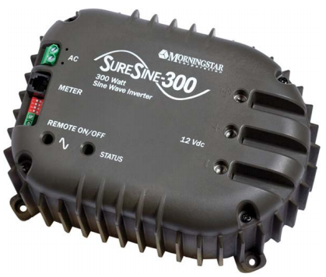Model number: SI-300-115V-UL (60Hz)

Company: Morningstar

Company Website: <https://www.morningstarcorp.com/>

Product Page: <https://www.morningstarcorp.com/products/suresine/>

**Details:**

Data Communications: RJ-11Connection with Morningstar Meterbus / MODBUS RTU (16-bit)

Continuous Power Rating: 300W @ 25 C

Peak Power Rating (10 minutes): 600W

DC input voltage: 10.0V - 15.5 V

Waveform: Pure Sine Waveform

AC Output Voltage (RMS): 220V or 115V +/- 10%

AC Output Voltage Frequency: 50 or 60 Hz +/- 0.1%

Peak efficiency: 92%

Total Harmonic Distortion (THD): < 4%

Self Consumption:

Inverter On (no load): 450mA

Inverter Off: 25mA

Stand-by: 55mA

Low voltage Disconnect (LVD): 11.5V or 10.5V

Low Voltage Reconnect; 12.6V or 11.6V

LVD Warning Threshold (buzzer): 11.8V or 10.8V

LVD Delay Period: 4 minutes

High voltage disconnect: 15.5V

High Voltage Reconnect: 14.5V

Standby On Threshold: ~8W

Standby Off Threshold: ~8W

High Temperature Disconnect: 95 C (heatsink)

High temperature reconnect; 80 C (heatisnk)

**Electronic Protections:**

Reverse Polarity (fused)

AC Short Circuit

AC overload

DC Terminals: Max wire size:

– 2.5 to 35 mm^2 / 14 to 2 AWG

Remote On/Off terminals: Max. Wire size:

– 0.25 to 1.0 mm^2 / 24 to 16 AWG

Enclosure: IP20

Cast anodized Aluminum

**Physical Characteristics:**

Dimensions: 213 x 152 x 105 mm (8.4 x 6.0 x 4.1 in)

Weight: 4.5 Kg/10.0lbs

AC terminals: Max wire size:

– 4 mm^2 / 12AWG

**Environmental Protections:**

Ambient Operating Temperature: -40 C to +45C

Storage Temperature: -55 C to +85C

Humidity: 100% (non-condensing)

Tropicalization: Conformal coating on PCBs. Epoxy encapsulated transformer and inductors.

# Accessories:

3A fuse

100A fuse

GFCI outlet:

Model: 15 Amp Self-Test smartlock pro slim duplex GFCI Outlet, white

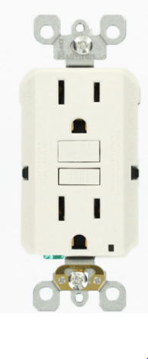Company: Home Depot

Company Website: <https://www.homedepot.com/>

Product Page: <https://www.homedepot.com/p/Leviton-15-Amp-Self-Test-SmartlockPro-Slim-Duplex-GFCI-Outlet-White-R02-GFNT1-0KW/206001533>

GFCI outlet box:

Model: 1-Gang Weather Box While-In-Use cover

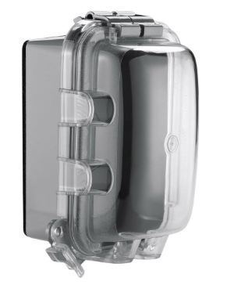Company: Home Depot

Company Website: [https://www.homedepot.com](https://www.homedepot.com/)

Product Page: [https://www.homedepot.com/p/1-Gang-Weather-Box-While-In-Use-Cover-WIU-1/206469236?cm_mmc=Shopping%7CG%7CVF%7CD27E%7C27-6_CONDUIT-BOXES-FITTINGS%7CNA%7CPLA%7c71700000033099037%7c58700003867178937%7c92700031086148565&gclid=EAIaIQobChMI2PLwrenQ4wIVAf_jBx2q5Q92EAkYASABEgKGrPD_BwE&gclsrc=aw.ds](https://www.homedepot.com/p/1-Gang-Weather-Box-While-In-Use-Cover-WIU-1/206469236?cm_mmc=Shopping|G|VF|D27E|27-6_CONDUIT-BOXES-FITTINGS|NA|PLA|71700000033099037|58700003867178937|92700031086148565&gclid=EAIaIQobChMI2PLwrenQ4wIVAf_jBx2q5Q92EAkYASABEgKGrPD_BwE&gclsrc=aw.ds)

Recommended Accessories:

RJ-11 Meterbus to USB MODBUS adapter

Model: Morningstar USB MeterBus Adapter > UMC-1

Company: Morningstar

Company Website: [https://www.morningstarcorp.com](https://www.morningstarcorp.com/)

Product Page: <https://solarflexion.com/umc-1?_vsrefdom=adwords&gclid=EAIaIQobChMIs6q9_eTQ4wIVef_jBx3u-AdIEAQYBSABEgKaCPD_BwE>

RJ-11 data communications cable

Model: USB Meterbus Adapter

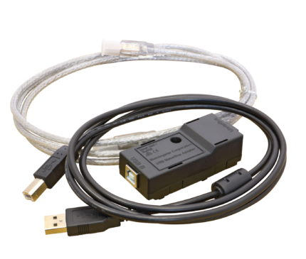Company: Morningstar

Company Website: <https://www.morningstarcorp.com/>

Product Page:<https://www.morningstarcorp.com/products/usb-meterbus-adapter/>

# GSM module

Explanation:

I don’t like the FONA module. I would like to replace it. I would like to instead use this GSM/GPRS shield. It slides easily onto the master Raspberry Pi, and can also fit another shield onto it if so desired. I will be fabricating a faculty sensor shield utilizing the I2C protocol. This shield utilizes the UART protocol. The Raspberry Pi can only accommodate 1 use of the UART protocol using the GPIO pins. The others will be using the Virtual COM ports of the Raspberry Pi. The Tristars will be using a RS-232 to USB converters with an FTDI chip installed in them for communication, and the BMS system will be using a split-open USB wire that will connect directly to the BMS control unit.

Name: Raspberry Pi GSM/GPRS Shield

SKU: S13

Company: Sixfab

Company webpage: <https://sixfab.com/>

Product page: <https://sixfab.com/product/gsmgprs-shield/>

s

Features:

Fully compatible with Raspberry Pi models that have the 40-pin GPIO header (3, 2, B+, A+, Zero)

High Data Speed: GPRS Multi-slot class 12, 85.6kbps downlink and 85.6kbps uplink data rates

Quad-band: 850/900/1800/1900MHz

Built-in PCB antenna, also there is an external antenna port available

Supported Protocols: TCP/ UDP/ PPP/ FTP/ HTTP/ SMTP/ CMUX/ SSL

Quectel’s QuecLocator Feature, lets you get the location without GPS/GNSS

Extremely low standby power consumption by M66, 1.3mA at DRX=5

Efficient and low quiescent current regulator circuit can hold up to 3.6A

Bluetooth Function, V3.0 specification, SPP and OPP profiles available.

Micro SIM Card socket can easily reachable on the downside of the shield.

Can be used standalone with PC/Laptop over micro USB, without stacking with Raspberry Pi thanks to FTDI chip on the shield.

Sending/Receiving standard V.25ter AT commands over UART port to Raspberry Pi is available

Working temperature range: -30°C to +80°C

# SIM card

Explanation:

If we will be sending data with our GSM module, we must have a SIM card to tell the cell phone tower what carrier we are using, and if we have permission to use their cell phone tower. The SIM card only stores 1 piece of data: our ID number. That’s all it does, but it’s very important.

Model: Ting GSM SIM card

Quantity: 1

Carrier: Ting

Company Website: <https://ting.com/>

Product Page: <https://ting.com/shop/gsmSIM>

You must register with Ting and pay a monthly fee of $50 for an unlimited 2G service plan.

# Web Server

Explanation:

We must have a server to send the data to. I’m sending all my data in JSON format so it’s easier for the website to read it.

In my down time (when I’m too tired to work on electronics), I would like to work on the website.

Crossing the bridge when we get to it.

Host: ucsc.edu

Website link: arboretum-backend.soe.ucsc.edu/

Server Location: ???

Who to call when things go bad: ???

Uptime Percentage: ???

Language Programmed in: ???